**Annexure II**

**PROJECT REPORT**

**ON**

BitCoin Price Prediction

**SUBMITTED**

**TO**

**DEPARTMENT OF COMPUTER SCIENCE AND ENGINEERING**

**FOR**

**INTEGRATED PROJECT (CS203 )**

**Submitted By:**

**Name(s): Tanishq Soni**

**University Roll No(s).: 1810991637**

**Semester: 6th**

**Session: 2018-2022**

**Index**

|  |  |  |
| --- | --- | --- |
| **Sr. no** | **Topic** | **Page No** |
| 1 | Problem Statement |  |
| 2 | Title of project |  |
| 3 | Objective & Key Learning’s |  |
| 4 | Options available to execute the project |  |
| 5 | Advantages/ Disadvantages |  |
| 6 | References |  |

**Problem Statement:**

To make bitcoin price prediction using python

**Title of project:**

Bitcoin price prediction

**Objective & Key Learnings:**

* To predict the price of bitcoin using python and Long Short-Term Memory.
* To understand the working of algorithm in python and build an model.
* Understanding the usage of libraries.

**Project implementation with output:**

Python:

Install the necessary packages and libraries

**Loaded libraries:**

Numpy , matplotlib.pyplot , pandas , sklearn.preprocessing , LSTM, Dense , Dropout

Output :

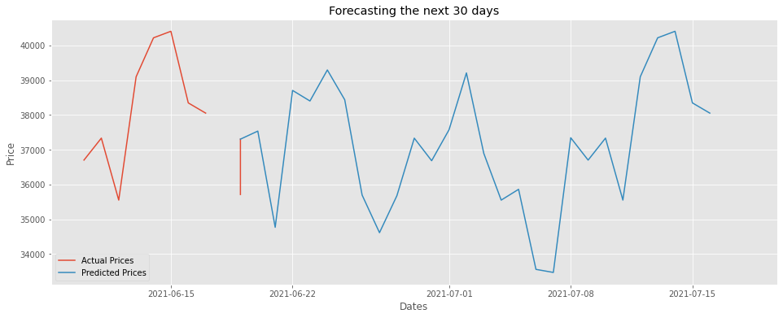

**REFERENCES**

1. <https://in.finance.yahoo.com/quote/BTC-USD/history?period1=1514764800&period2=1624060800&interval=1d&filter=history&frequency=1d&includeAdjustedClose=true&guccounter=1>
2. <https://www.youtube.com/>
3. https://github.com/crypto-code/Stock-Market-AI-GUI